

**Contact**

**Send you Cv’s to** [**hr@mazco.com.sa**](mailto:hr@mazco.com.sa)

**Or**

**Post Box: 2486, Dammam 31451,**

**KINGDOM OF SAUDI ARABIA.**

**Tell: +966 3 8260080 EXT: 31**

**Fax : +966 3 8266618**

**Website::**[**www.mazco.com.sa**](http://www.mazco.com.sa)

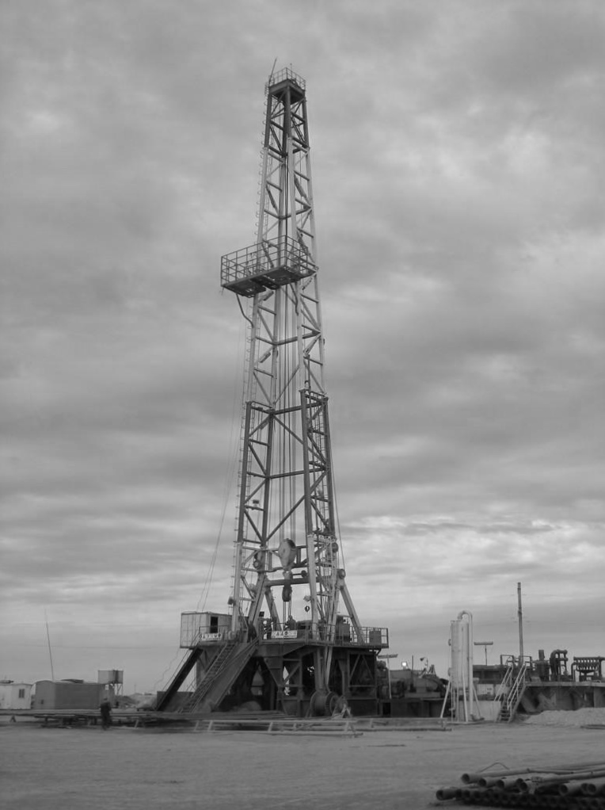

**Job Description:**

Derrick Man shall:

* + - Load and unload boats and trucks safely.
    - Working on rig floor: demonstrate the ability to successfully handle tubulars utilizing the proper equipment and technique, namely air, top drive, rig tongs, chain tongs pipe spinners, iron rough neck, collar clamp, etc.
    - Adequately apply safety precautions while testing, logging, etc.
    - Perform routine maintenance on rig floor and handling tubular goods: understand and demonstrate the ability to conduct minor repair of rig tongs, chain tongs, pipe slips, collar lamp and pipe elevator.
    - Inspect and maintain tubular box and pin connection, dies, nuts, bolts, on drilling equipment for wear and/or damage.
    - Perform pump house operation, assist in maintaining/repairing mud pumps and participate in mixing/maintaining drilling fluids.
    - Perform under general supervision, minor electrical work, heavy carpentry, metal cutting, pipe filling, machine maintenance and others.

**Qualification:**

* + Have a minimum of four years training on the job and experience as a rig man, including both floor and derrick work.
  + Must able to understand work directions in English.
  + Familiar with the nomenclature of rotary drilling equipment.
  + Must possess physical stamina.
  + Have a good sense of balance and coordination to be able to work safely at heights in excess of 100 feet.
  + Willing to perform hard and hazardous work under extreme weather conditions involved in drilling wells and living at isolated well sites.

Derrick Man